Ex1
the problem is caused by collections; in fact when we work on the sharedMap we have visibility problems. We could fix this problem using lock, but it doesn’t give performance. A better solution could be concurrent collection.
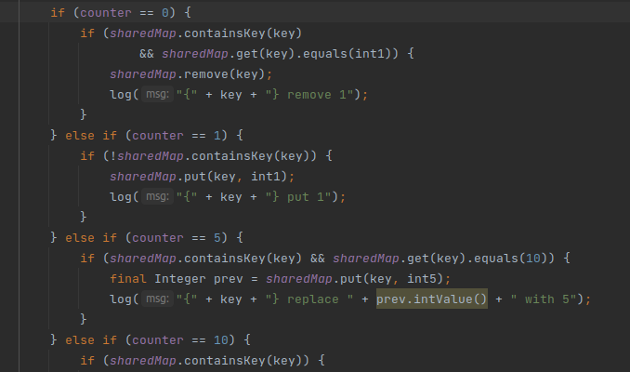
The code up show the critical code that gives visibility problems.
private final static ConcurrentMap<String, Integer> sharedMap = new ConcurrentHashMap<>();//problem

the code up shows the creation of a concurrent hasmap that provides all functionalities to avoid the previous problem

